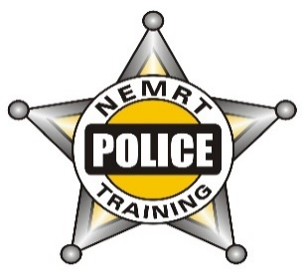
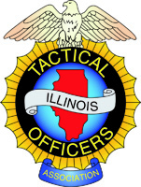
The Illinois Tactical Officers Association, NEMRT, NIPSTA and the Glenview Police Department are pleased to offer this dynamic training opportunity:

Master Tactical Patrol Officer Instructor

The ITOA's Master Tactical Patrol Officer (TPO) Program is a training and recognition initiative that provides instructor training and certification for instructors who complete the entire Master TPO curriculum.

To enhance the ability of instructors to obtain the Master TPO designation, we are pleased to offer the entire Master TPO Instructor curriculum in collaboration with NEMRT, NIPSTA and the Glenview Police Dept.

This training opportunity allows those seeking Master TPO designation an opportunity to finish the courses they still need or provides the opportunity for an officer to complete the entire Master TPO requirements by completing all five of the listed courses.

Courses and dates being offered will be:
- High Risk Patrol Operations Instructor March 29-30-31, 3pm-11pm
- Rapid Deployment – Active Threat / Solo Officers Response Instructor April 19-23, 3pm-11pm
- Rescue Task Force Instructors course May 10-11, 3pm-11pm
- Immediate Trauma Care Self-Aid / Buddy-Aid Instructor May 31-Jun2, 9am-5pm
- MACTAC – Urban Tactics Instructor June 27-28-29, 9am-5pm

This flier is being released to allow officers the opportunity to begin working on their schedule and beginning
to plan for the courses that they will be attending.

The First course is “LIVE” for registration at itoa.org in the training link. More to follow!

TO REGISTER: Go to ITOA.org, click on “TRAINING” and review the course list. Once you find the
course you want to register for, click on and follow the directions. You can also register and pay for 2 or
more classes with 1 transaction by contacting admin@itoa.org.

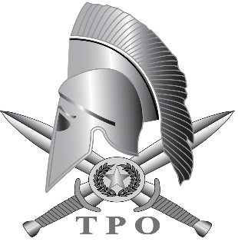
MASTER TACTICAL PATROL OFFICER

